Allison Dalton and Jason Gustafson

Report: The Texan Duck Curve

How people use their power, as an electrician, is a critical step towards the future of renewable energies, particularly solar power. Since solar power is powered by the sun, its peak hours of generation are around noon with an overall normal distribution around it in how much energy produced. What we wanted to further understand is the pattern of energy use for consumers because people’s demand for electricity might not match the output for solar. As a result, either solar must be stored in batteries or another source, such as wind, must be used instead for particular regions. California has largely faced this problem as they heavily invest in solar energy, but experience what they call a “duck curve” in electricity consumption, meaning their pattern is in the shape of the side profile of a duck. It demonstrates solar output rarely matches energy demand.

We want to investigate another state, Texas, that also has great potential for solar energy due to its southern geography and for the size of its major cities. From Kaggle.com we found data on the hourly energy consumption of Dallas, San Antonio, and Houston from July 2018 until May 2020. With this data, we hoped to be able to fit it to the general shape of the duck curve which we generated using basic polynomial trends. This equation comes out to be generally in this shape: power consumption = β5 x5 -β4 x4 +β3 x3 -β2 x2 +β0. For each city, we grouped by military hour by averaging nearly two years of data for each hour. After further manipulation of the data frame for easier functionality, we feed each city's data into a curve fitting optimizer to receive those Beta values of our formula. With those put into a new data frame, we then created graphs showing the curve against the actual data points for visual reference.

After investigating our data, we were able to see and conclude different trends about each city and their energy consumption on an hourly basis. In the appendix below we have attached a graph that is also in the dashboard to be referenced in this analysis. Overall, it is evident there are different uses of energy for the three cities depending on their general population and business sector needs, but the patterns that each form are all similar. All three appear to follow the duck curve rather well, consistently following the actual data points on the graphs. Although each pattern is generally in the same shape for each city, the curve fitting did a nice job at altering the Betas to better fit the differing slopes of the changing electricity needs. For example, Dallas and Houston have a rather dramatic change from morning to night usage while San Antonio’s is more gradual, both demonstrated in the curve and in the scatter points.

One weakness of our generated curve is in the early morning hours from midnight to about 0500 hours it appears to be slightly off. The curve overestimates energy consumption at night and then overestimates until sunrise, compared to the actual mean data points. This would be problematic for managers of the electric grid because precision is needed in determining how much energy should be used as to not overload or underload their systems. Further analysis should be conducted to solve this issue.

To conclude, using curve fitting has proved to be valuable in producing trends, in this case in showing overall patterns in electricity consumption for major Texan cities. This analysis can be extremely useful as cities look towards the future of energy consumption and how it would relate towards using more renewable energies that are not as consistent in output as current sources of coal and natural gas. With the knowledge that these three large cities follow a similar energy consumption trend, further investigation into other cities, especially in other states and countries, can expand upon this research towards infrastructure that is both environmentally friendly and sustainable.

Appendix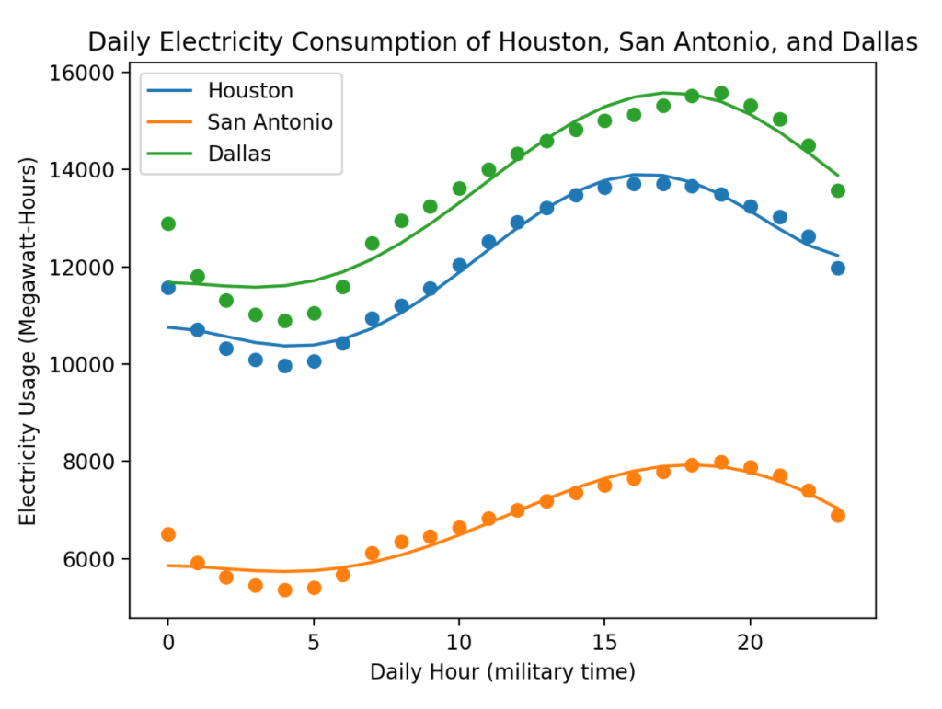

Figure A

Links to Other Parts of the Project:

GitHub Repository: <https://github.com/allisondalton/FinalProject.git>

Dashboard: <https://pure-woodland-58846.herokuapp.com/>